INTERNET OF THINGS

Arduino

Arduino is an Embedded development platform that consists of both the hardware as well as software parts. Arduino is an open-source electronics platform based on easy-to-use hardware and software. [Arduino boards](https://www.arduino.cc/en/Main/Products) are able to read inputs - light on a sensor, a finger on a button, or a Twitter message - and turn it into an output - activating a motor, turning on an LED, publishing something online. You can tell your board what to do by sending a set of instructions to the microcontroller on the board. To do so you use the [Arduino programming language](https://www.arduino.cc/en/Reference/HomePage) (based on [Wiring](http://wiring.org.co/)), and [the Arduino Software (IDE)](https://www.arduino.cc/en/Main/Software), based on [Processing](https://processing.org/).

**Arduino - Hardware Design**

What’s Arduino hardware? It's a PCB-mounted microcontroller that you can program and use for simple daily tasks, mathematical computations, and prototyping and testing. An **Arduino development board** consists of the core microcontroller with its supplementary components and the necessary circuitry to communicate with the PC which we will be using for both communications as well as programming the microcontroller. For communication or programming purposes, we will be using a **USB to TTL converter**, which will be embedded within the Arduino board. So, if we look into an Arduino board at a block level it will look like this

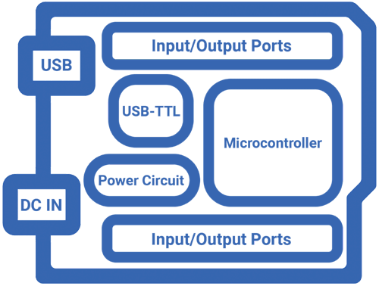

Component of aurdino uno board

In the UNO board, the main component is the **ATMega328P**. It is the heart of the Arduino UNO. Near the MCU you can see a 16MHz resonator which will give the ATMega328P the clock signal to work. Near that, you can also see a connector named ICSP. It is used to burn the **Arduino bootloader**into the chip. And you can also see the header pins for the I/O.

If you look at the other side of the board, you can spot another microcontroller in a QFN package. It is an **ATMega16U** and is used as a USB -TTL converter. Near that, it will have its crystal and ICSP port to burn the firmware. There will be a reset button near it, which will reset the ATMega328P.

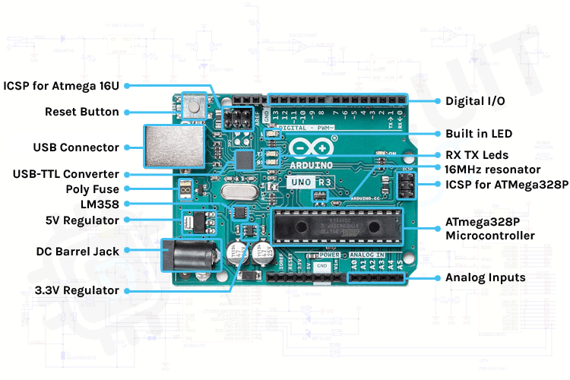You can see the USB port and DC barrel jack on the left side. You can power the Arduino either through the USB port or the barrel jack. The barrel jack will accept a voltage range of 7-12V. And near the barrel jack, you can find two voltage regulators. One for 5V and one for 3.3V. Let’s check out each component.

**USB - B Socket**

The USB socket on the UNO has two functions. One is for communication, to connect with the computer through a USB port, and also to load the firmware into the Arduino with the help of the bootloader. The second is to power the Arduino. You can use the USB port to power the Uno directly from any USB port.

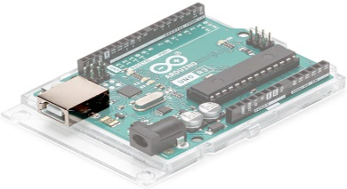

**ISCP Pins**

In the UNO you can find two 6 pin connectors. One is near the USB – TTL Chip and the other one is at the end of the board. These pins are used to program those two microcontrollers. The USB – TTL chip on this board is an ATMgega16U. The connector marked as 1 is used to program the USB-TTL firmware into this chip. And the connector marked as 2 is used to burn the bootloader into the ATMega328 microcontroller.

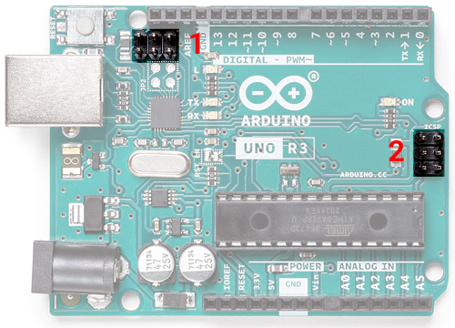

**Reset Button**

As the name indicates this tactile switch is used to reset the ATMega328 microcontroller. It’s connected to the PC6/Reset pin, which is pulled up through a 10K. When the switch is pressed the pin is pulled to the ground and the chip will reset.

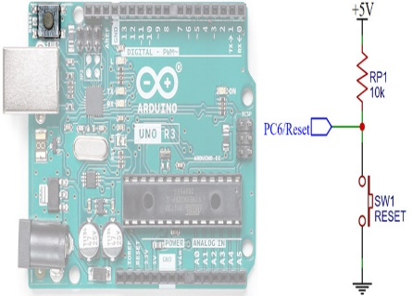

**USB-TTL Interface Chip**

To communicate with the computer, the Arduino relies on a USB-TTL interface. In UNO, ATMega16U with custom firmware act as a USB – TTL interface chip.

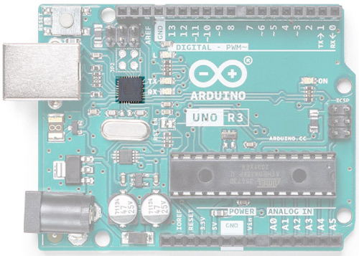

**Crystal Oscillator/ Ceramic resonator**

For a microcontroller to work it needs a clock source. The clock circuit determines the speed with which the microcontroller operates. How many instructions per second it will execute is dependent on the clock frequency. The ATMega series microcontrollers can use two types of clock sources. One is an internal RC oscillator that is already built into the microcontroller. But the drawback of using the internal oscillator is that its maximum frequency is limited and it is not that accurate. That is where the second option comes into place, i.e., using an external clock generator. In this case, we will be using a Quartz crystal oscillator or a ceramic resonator for this purpose. In the picture below, you can see two components are marked. The first one is a 16MHz crystal oscillator used for the ATMega16U2 chip and the second one is a 16MHz resonator used for the ATMega328P microcontroller.

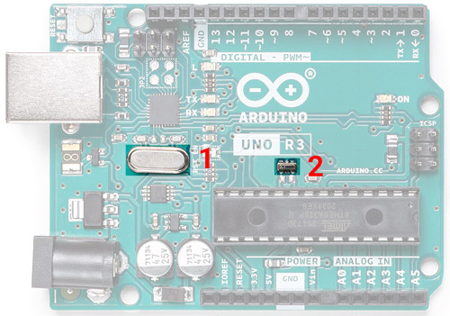

**Power Path control**

If you inspect a UNO, you can find an LM358. You might think what’s its role here. It’s used as a comparator to control the input power path. When the input power is provided through the barrel jack or Vin pin the power path control circuit will cut off the USB power pin from the circuit which in fact will protect the USB port.

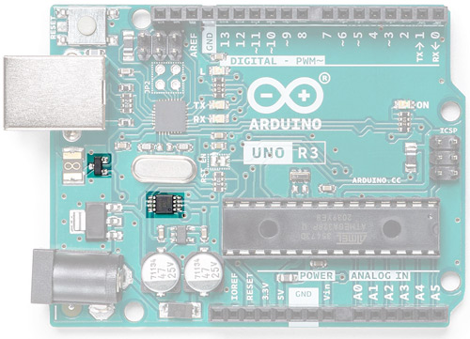

**Voltage Regulator**

The ATMega328 and ATmega16U2 have a maximum input voltage of around 5V and most modules or accessories work on either 5V or 3.3V. The Arduino can accept 7-12V through the Vin pin or the DC barrel jack. So, to step it down, there are two regulators onboard. One is a 5V regulator (marked as 1) for the microcontrollers and the other one is a 3.3V regulator which is used to provide 3.3V through 3.3V pin.

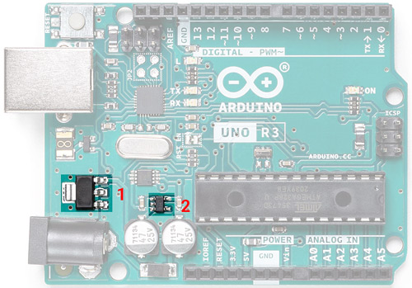

**DC Barrel Jack**

The DC barrel jack is used to supply power to the UNO. We can supply 7-12V through it and hence we can use a 12V DC adapter or 9V DC adapter on this Jack to power the Arduino board.

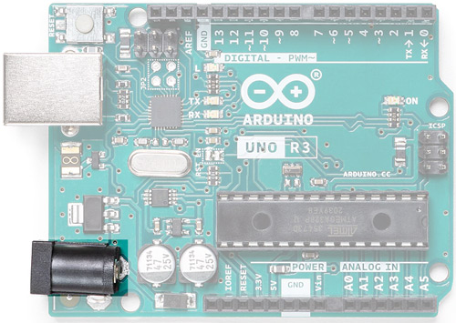

**Digital and Analog I/O**

The Arduino UNO has 14 digital I/O pins and 6 Analog inputs. The digital I/O pins are 5V logic level and you can also use the Analog pins as digital I/O too. Arduino UNO supports 6 channel 10 bit ADC inputs through A0-A5, which can be sampled and analyzed using UNO.

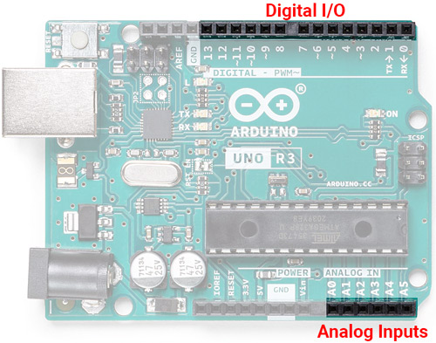

**Status LEDs and Inbuilt LED**

Uno has 4 LEDs onboard. One is used as a power indicator and two are used to show the activity of the Rx and Tx pin. The other one is tied to the Digital pin 13, which can be used to test the Arduino board or simply as an indicator.

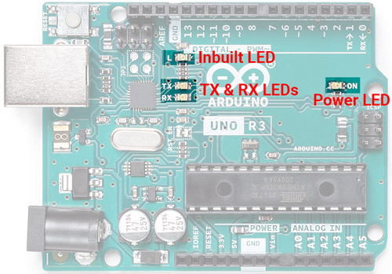

**ATMega328P – The Brain**

Last but not least is the main component on the Arduino board – the ATMega328P Microcontroller. UNO uses a 28Pin DIP version of ATMega328P. Atmega328P is pre-programmed with a bootloader that allows you to directly upload the program to Arduino through USB without the need for an external programmer.

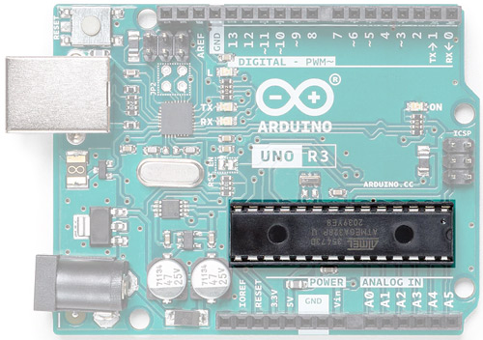

**Raspberry Pi**

Raspberry Pi is the name of a series of single-board computers made by the [Raspberry Pi Foundation](https://www.raspberrypi.org/about/), a UK

The Raspberry Pi launched in 2012, and there have been several iterations and variations released since then. The original Pi had a single-core 700MHz CPU and just 256MB RAM, and the latest model has a quad-core CPU clocking in at over 1.5GHz, and 4GB RAM. The price point for Raspberry Pi has always been under $100 (usually around $35 USD), most notably the Pi Zero, which costs just $5.

The Raspberry Pi is a very cheap computer that runs Linux, but it also provides a set of GPIO (general purpose input/output) pins, allowing you to control electronic components for physical computing and explore the Internet of Things (IoT).

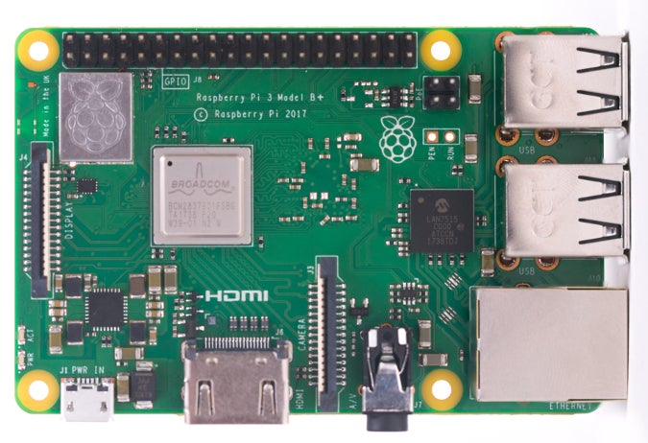

# Jump wire

A **jump wire** (also known as **jumper**, **jumper wire**, **DuPont wire**) is an [electrical wire](https://en.wikipedia.org/wiki/Electrical_wire), or group of them in a cable, with a connector or pin at each end (or sometimes without them – simply "tinned"), which is normally used to interconnect the components of a [breadboard](https://en.wikipedia.org/wiki/Breadboard) or other prototype or test circuit, internally or with other equipment or components, without soldering.[[1]](https://en.wikipedia.org/wiki/Jump_wire#cite_note-1)

* Solid tips – are used to connect on/with a breadboard or female header connector. The arrangement of the elements and ease of insertion on a breadboard allows increasing the mounting density of both components and jump wires without fear of short-circuits. The jump wires vary in size and colour to distinguish the different working signals.
* [Crocodile clips](https://en.wikipedia.org/wiki/Crocodile_clip) – are used, among other applications, to temporarily bridge sensors, buttons and other elements of prototypes with components or equipment that have arbitrary connectors, wires, [screw terminals](https://en.wikipedia.org/wiki/Screw_terminal), etc.
* [Banana connectors](https://en.wikipedia.org/wiki/Banana_connector) – are commonly used on test equipment for DC and low-frequency AC signals.
* [Registered jack](https://en.wikipedia.org/wiki/Registered_jack) (RJnn) – are commonly used in telephone (RJ11) and computer networking (RJ45).
* [RCA connectors](https://en.wikipedia.org/wiki/RCA_connector) – are often used for audio, low-resolution composite video signals, or other low-frequency applications requiring a [shielded cable](https://en.wikipedia.org/wiki/Shielded_cable).
* [RF connectors](https://en.wikipedia.org/wiki/RF_connector) – are used to carry [radio frequency](https://en.wikipedia.org/wiki/Radio_frequency) signals between circuits, test equipment, and antennas.
* RF jumper cables - Jumper cables is a smaller and more bendable corrugated cable which is used to connect antennas and other components to network cabling. Jumpers are also used in base stations to connect antennas to radio units. Usually the most bendable jumper cable diameter is 1/2".

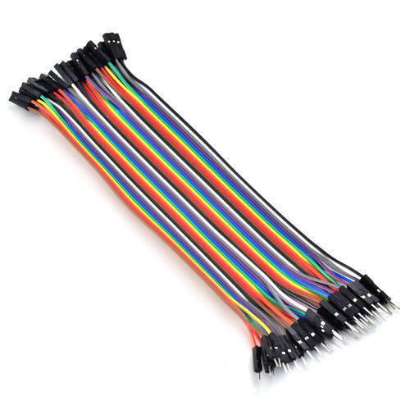

# Breadboard

A **breadboard**, or protoboard, is a construction base for [prototyping](https://en.wikipedia.org/wiki/Prototype) of [electronics](https://en.wikipedia.org/wiki/Electronic_circuit). Originally the word referred to a literal bread board, a polished piece of wood used when slicing bread.[[1](https://en.wikipedia.org/wiki/Breadboard#cite_note-1)

The breadboard is a white rectangular board with small embedded holes to insert electronic components. It is commonly used in electronics projects. We can also say that breadboard is a prototype that acts as a construction base of electronics.

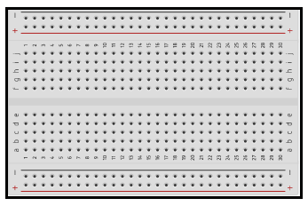

A breadboard is also categorized as a **Solderless board**. It means that the component does not require any soldering to fit into the board. Thus, we can say that breadboard can be reused. We can easily fit the components by plugging their end terminal into the board. Hence, a breadboard is often called a **plugboard**.

### **Types of Breadboard**

There are two types of the breadboard, namely **Solderless** and **solder breadboard**.

Let's discuss the above two types of the breadboard in detail.

**Solderless breadboards**

As the name implies, Solderless boards do not require any soldering after the electronic components are plugged in.

The leads or ends of the components are inserted into the holes of a breadboard for its functioning.

**Solder breadboard**

The solder breadboard is also a board that has a tiny hole embedded into it. We can insert the terminal of the electronic components into the board. After the connection is rechecked, we can solder these components.

The common difference between solder and Solderless breadboards is the **reusability**.